id | firstname | lastname | position_id | gender | salary | date_hired | Status
1 | Jerwin | Cruz | 1 | M | 60000.00 | 2018-06-30 | ACTIVE
2 | Peter | Parker | 2 | M | 65000.00 | 2011-12-02 | ACTIVE
3 | Tony | Stark | 2 | M | 102000.00 | 2002-02-01 | ACTIVE
4 | Natasha | Romanoff | 4 | F | 70000.00 | 2015-10-24 | ACTIVE
5 | Wanda | Maximoff | 3 | F | 48000.00 | 2016-09-25 | ACTIVE
6 | Steve | Rohers | 1 | M | 58000.00 | 2017-07-25 | ACTIVE
7 | Stephen | Strange | 5 | M | 52000.00 | 2013-08-25 | ACTIVE

Daniel Alistair W. Lopez
BSCS – 2A
- Display all records if the employee’s gender is male and hired from 2013 to present.
- Display firstname if the employee’s gender is male and second letter of lastname is letter ‘a’.
- Display firstname if the employee’s gender is male and fourth letter of lastname is letter ‘a’.
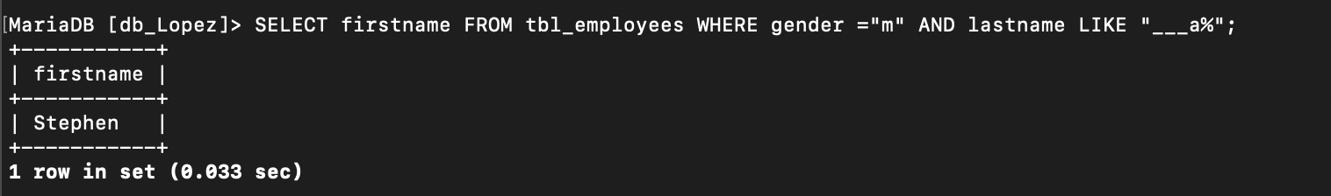
- Display the maximum salary.
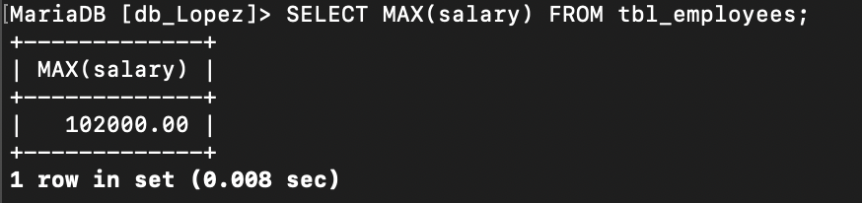
- Display the average salary.
- Display firstname if the employee’s gender is male and fourth letter of lastname is letter ‘p’.
- Display the firstname of the employee if the salary is above 53000.
- Display firstname of the top 3 employee with highest salary.
- Display firstname of the top 2 employee with lowest salary.
- Display firstname of the top 2 male employee with lowest salary.

